|  |
| --- |
| **Hulland Church of England Primary School**  **Firs Avenue, Hulland Ward, Derbyshire, DE6 3FS**  **Executive Headteacher – Mr T Taylor** |

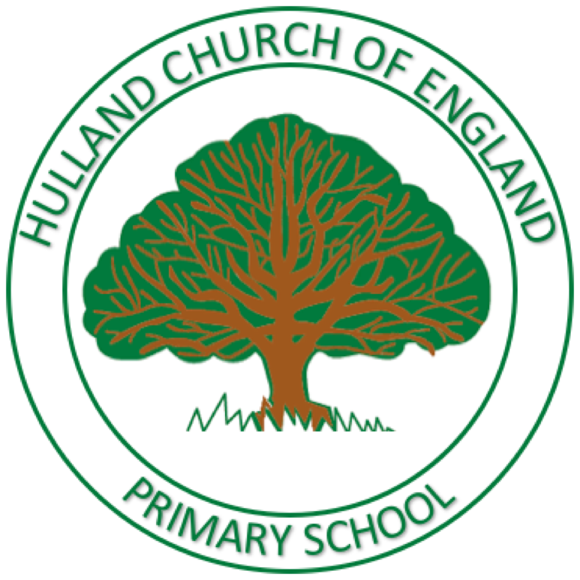

Dear Parents and Carers 9th December 2024

**Arbor Parent Portal -**

**Going live from 1st January 2025**

We are writing to let parents know that we are moving management and communication systems, and from January 2025, we will be using Arbor for our communication and payment system.

With Arbor, it will allow the school to communicate with parents more efficiently and bring all core school data into one system. The Arbor App and Parent Portal will mean we can keep you informed about your child’s life at school in a much more accessible way. You will be able to do the following all from the same system:

* Pay for school lunches, trips, clubs, activities
* Book and pay for wraparound sessions
* Update your child’s information directly
* Give permissions and consents instead of filling paperwork in
* Get live updates
* Access to the free Parent Portal app, for instant notifications

**How to get started**

1. A welcome email will be sent out to your email to set up a password (please check your junk/clutter folders) We will let parents know when this goes out.
2. Click the link in your welcome email to set up your password
3. Go to the App or Google Play Store on your phone and search ‘Arbor’
4. Click ‘Install’ on Android or ‘Get’ on iPhone then open the App
5. Enter your email, select the school, then enter your password
6. Accept the Terms and Conditions and enter your child’s birthday

Please contact the school office if you have any questions about Arbor, the App or the Parent Portal. Also, for handy tips how to pay for school meals, clubs/trips or booking sessions for wraparound care, please use <https://support.arbor-education.com/hc/en-us/sections/12209476383517-Parent-Portal-and-Arbor-App-Payments-School-Shop-Meals-Clubs-and-Trips>

**BACS payments will no longer be in use from 1st January 2025.**

**We are asking parents to clear the outstanding balances on their child’s account by 20th December 2024 and begin to make payments on Arbor from 1st January 2025.**

**Any credits and refunds due, will be reimbursed week commencing 7th January 2025**.

Thank you for your co-operation.

Kind Regards,

Mr Taylor

Executive Headteacher